Music Mobile App

**Software Development Plan (Small Project)**

**Version 1.**1

**Revision History**

| **Date** | **Version** | **Description** | **Author** |
| --- | --- | --- | --- |
| 30/10/22 | 1.0 | Initial Project Plan of Music Mobile App | Nguyễn Phước Gia Huy  Phạm Trần Minh Ngọc |
| 26/11/22 | 1.1 | Update and fix part 4.2 | Nguyễn Phước Gia Huy  Phạm Trần Minh Ngọc |
|  |  |  |  |
|  |  |  |  |

**Table of Contents**

**1. Introduction** **4**

1.1 Purpose 4

1.2 Scope 4

1.3 Overview 4

**2. Project Overview** **4**

2.1 Project Purpose, Scope, and Objectives 4

2.2 Assumptions and Constraints 4

2.3 Project Deliverables 5

**3. Project Organization** **5**

3.1 Organizational Structure 5

3.2 Roles and Responsibilities 5

**4. Management Process** **5**

4.1 Project Estimates 5

4.2 Project Plan 6

4.2.1 Phase Plan 6

4.2.2 Iteration Objectives 6

4.2.3 Releases 6

4.2.4 Project Schedule 6

Sprint 01 - PA01 6

Sprint 02 - PA02 7

Sprint 03 - PA03 8

Sprint 04 - PA04 9

Sprint 05 - PA05 10

Sprint 06 - PA06 11

4.2.5 Project Resourcing 11

4.3 Project Monitoring and Control 11

4.3.1 Requirements Management 11

4.3.2 Reporting and Measurement 11

4.3.3 Risk Management 11

4.3.4 Configuration Management 12

**Software Development Plan (Small Project)**

# **Introduction**

This document is the Software Development Plan for a project called a music mobile app. It includes the purpose, scope, definitions, acronyms, abbreviations, references, and overview of this Software Development Plan.

## **Purpose**

The purpose of the *Software Development Plan* is to gather all information necessary to control the project. It describes the approach to the development of the software and is the top-level plan generated and used by managers to direct the development effort.

The following people use the *Software Development Plan*:

* The **project manager** uses it to plan the project schedule and resource needs, and to track progress against the schedule.
* **Project team members** use it to understand what they need to do, when they need to do it, and what other activities they are dependent upon.

## **Scope**

This *Software Development Plan* describes the overall plan to be used by the Music Mobile App project, including deployment of the product. The details of the individual iterations will be described in the Iteration Plans.  
The plans as outlined in this document are based upon the product requirements as defined in the *Vision Document*.

## **Overview**

This *Software Development Plan* contains the following information:

Project Overview — provides a description of the project's purpose, scope, and objectives.  It also defines the deliverables that the project is expected to deliver.

Project Organization — describes the organizational structure of the project team.

# **Project Overview**

## **Project Purpose, Scope, and Objectives**

The main purpose of the project is to create a product which helps users relax, entertain and create. Composers can post their own songs for everyone to enjoy.It will help composers become more known.

If this project is completed, it will be suitable for everyone(especially teenagers or music enthusiasts).

The Music Mobile App has the following main function:

* Play music.
* Download songs (Only Vip users).
* Upload songs(Artists).
* Recommended songs.
* Search.
* Management(Only admins).
* Have an Account.

The product in this project is a mobile app. It can approach users easily.

## **Assumptions and Constraints**

This plan is based on the budget, number of members, equipments, schedule of the team that apply on the project, which are:

* Budget: $100 ($20 each member).
* Number of members: 5.
* Schedule: the team must have meetings and plan every week in order to finish the given tasks of the PA deadlines.

## **Project Deliverables**

Deliverables for each project phase are identified in the Development Case, Deliverables are delivered towards the end of the iteration, as specified in section 4.2.4 Project schedule.

# **Project Organization**

## **Organizational Structure**

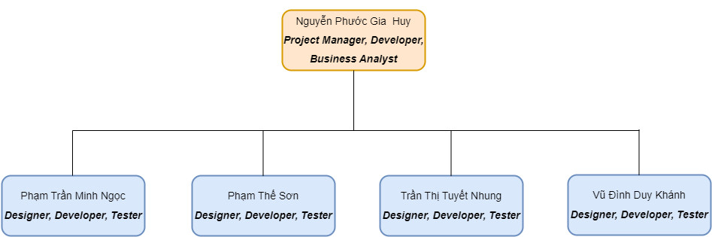

## **Roles and Responsibilities**

| **Person** | **Role** |
| --- | --- |
| **Nguyễn Phước Gia Huy** | Project Manager, Developer, Business Analyst. |
| **Phạm Trần Minh Ngọc** | Designer, Developer, Tester. |
| **Trịnh The Sơn** | Designer, Developer, Tester. |
| **Trần Thị Tuyết Nhung** | Designer, Developer, Tester. |
| **Vũ Đình Duy Khánh** | Designer, Developer, Tester. |

# **Management Process**

## **Project Estimates**

The project time estimates 12 weeks to build all product features. So dividing the total time of the project into 6 sprints, each sprint will have 2 weeks.

Each person has to work for a project for 3 hours/days at least. Each person works 3 days/week => Each person has to work for 3*3*12 = 108 hours.

## **Project Pla**n

### **Phase Plan**

The project time estimates 12 weeks to build all product features.

Our project has 5 Sprints (5 PAs - not including PA0) and each Sprints takes 2 weeks.

* PA01: 31/10/2022 - 12/11/2022
* PA02: 12/11/2022 - 26/11/2022
* PA03: 26/11/2022 - 10/12/2022
* PA04: 10/12/2022 - 26/12/2022
* PA05: 26/12/2022 - 09/01/2022

Resource: C# and xml.

### **Iteration Objectives**

List the objectives to be accomplished for each of the iterations:

* Sprints 01:Project plan, Vision Document, weekly report.
* Sprints 02:Use-case Specification, Use-case Model, Updated Vision Document and Project Plan.
* Sprints 03:Class Diagram, Basic mobile app (Sign in/out, Register).
* Sprints 04:Updated SAD, UI Prototype and App Features
* Sprints 05:Completed Mobile App with all given features, Test Plan, Test Cases (Test Report) and Powerpoint Presentation File

### **Releases**

Because there is quite a short time in this project, so we have only one software release.

### **Project Schedule**

### **Sprint 01 - PA01**

Starting date: 31/10/2022

Ending date: 12/11/2022

Estimated product: Vision Document, Project Plan

Plan:

* Project plan: 2/11-10/11
* Introduction: Phạm Trần Minh Ngọc
* Project Overview: Phạm Trần Minh Ngọc
* Project Organization: Phạm Trần Minh Ngọc
* Project Plan: Nguyễn Phước Gia Huy
* Project Monitoring and Control: Nguyễn Phước Gia Huy & Phạm Trần Minh Ngọc
* Vision document: 2/11-10/11
* Introduction: Trần Thị Tuyết Nhung
* Positioning: Trần Thị Tuyết Nhung
* Product Overview: Trần Thị Tuyết Nhung
* Stakeholder and User description: Vũ Đình Duy Khánh
* Product Features: Vũ Đình Duy Khánh
* Weekly report: 9/11 – 12/11: Trịnh Thế Sơn
* Weekly meeting: 2/11 & 9/11: All members

Gantt chart:

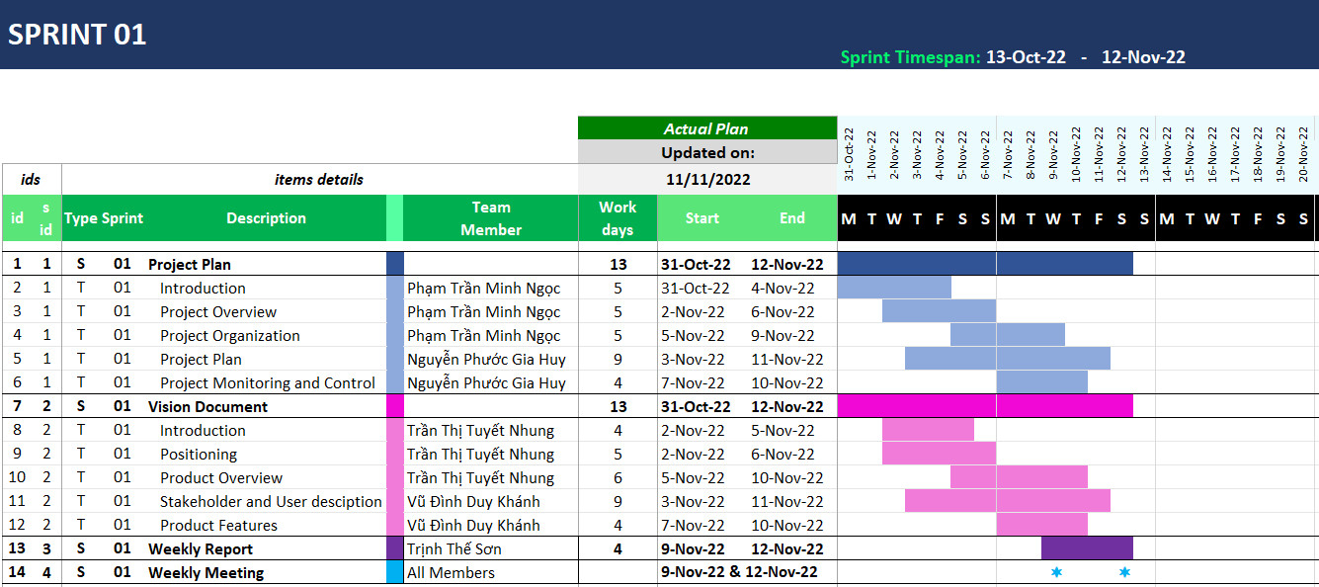

### **Sprint 02 - PA02**

Starting date: 12/11/2022

Ending date: 26/11/2022

Estimated product: Use-case Specification, Use-case Model, Updated Vision Document

Plan:

* Revised project plan -2nd submission: 16/11 – 20/11: Nguyễn Phước Gia Huy & Phạm Trần Minh Ngọc
* Detailed vision document - 2nd submission: 16/11 – 20/11: Trần Thị Tuyết Nhung & Vũ Đình Duy Khánh
* Use-case model:12/11-19/11:Vũ Đình Duy Khánh & Trần Thị Tuyết Nhung
* Use-case specification: 17/11 – 24/11 : Trịnh Thế Sơn & Nguyễn Phước Gia Huy & Phạm Trần Minh Ngọc
* Weekly report:23/11-26/11 :Trịnh Thế Sơn
* Weekly meeting: 16/11 & 23/11: All members
* Code Training: 12/11 -26/11: All members

Gantt chart:

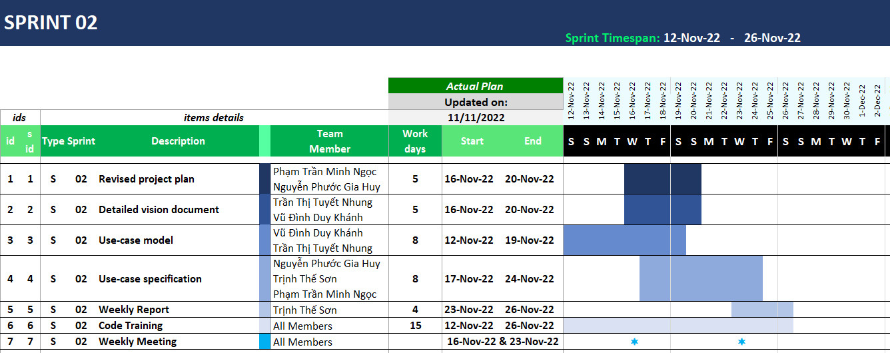

### **Sprint 03 - PA03**

Starting date: 26/11/2022

Ending date: 10/12/2022

Estimated product: Class Diagram, Basic mobile app (Sign in/out, Register)

Plan:

* Use-case specification – 2nd submission:30/11-4/12: Trịnh Thế Sơn & Nguyễn Phước Gia Huy & Phạm Trần Minh Ngọc
* Define software architecture: 26/12 – 6/12: Phạm Trần Minh Ngọc
* Class diagrams: 26/11 – 6/12: Trịnh Thế Sơn & Trần Thị Hồng Nhung
* Code Implementation: 2/12 – 8/12:
* Front-end: login, homepage: 2/12 – 8/12: Vũ Đình Duy Khánh
* Back-end: Server, Sign in/out: 2/12 – 8/12: Nguyễn Phước Gia Huy
* Weekly report: 7/12 – 10/12: Trịnh Thế Sơn
* Weekly meeting: 30/11 – 10/12: All members
* Code Training: 26/11 – 10/12: All members

Gantt chart:

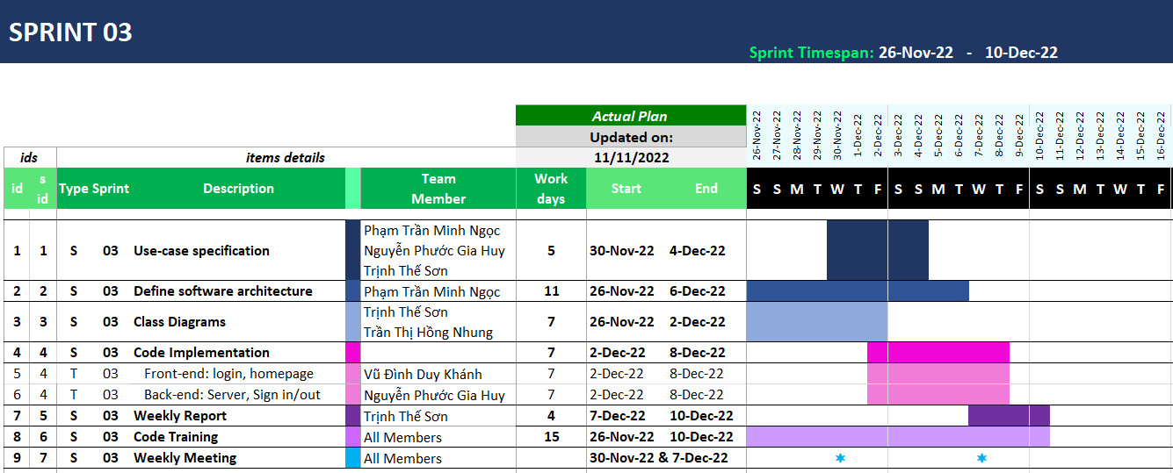

### **Sprint 04 - PA04**

Starting date: 10/12/2022

Ending date: 26/12/2022

Estimated product: updated SAD, UI Prototype and App Features

Plan:

* Revise SAD:10/12 – 16/12: Trịnh Thế Sơn & Phạm Trần Minh Ngọc
* Update section 1-4:
* Fill Section5:
* Fill Section 6:
* UI prototype:10/12 – 18/12: Trần Thị Hồng Nhung & Nguyễn Phước Gia Huy
* Code Implementation: 10/12 – 22/12:
* Back-end: all Feature left: 10/12 – 22/12: Vũ Đình Duy Khánh
* Front-end: all Feature left: 10/12 – 22/12 : Nguyễn Phước Gia Huy & Phạm Trần Minh Ngọc & Trịnh Thế Bảo & Trần Thị Hồng Nhung
* Weekly meeting: 14/12 & 21/12 : All members
* Weekly report: 21/12-24/12: Trịnh Thế Sơn

Gantt chart:

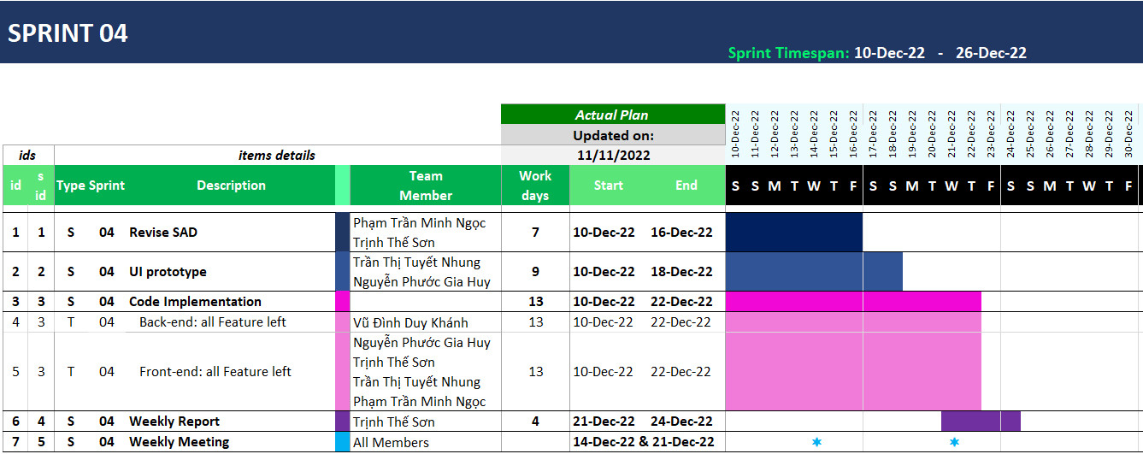

### **Sprint 05 - PA05**

Starting date: 26/12/2022

Ending date: 9/1/2023

Estimated product: Completed Mobile App with all given features, Test Plan, Test Cases (Test Report) and Powerpoint Presentation File.

Plan:

* Feature Implementation (if it can be finished in the earlier sprint): 26/12 – 30/12: All members
* Test plan, test cases (at least 25 test cases) and Report:26/12-5/1: Vũ Đình Duy Khánh & Trịnh Thế Sơn
* Project presentation (powerpoint and speech): 26/12 – 6/1:
* Powerpoint: 26/12 – 6/1: Trần Thị Hồng Nhung & Phạm Trần Minh Ngọc
* Speech: 26/12 – 6/1: Nguyễn Phước Gia Huy & Vũ Đình Duy Khánh
* Final submission:7/12-9/1: Nguyễn Phước Gia Huy
* Weekly meeting: 28/12 & 4/1: all members
* Weekly report: 4/1-7/1: Trịnh Thế Sơn

Gantt chart:

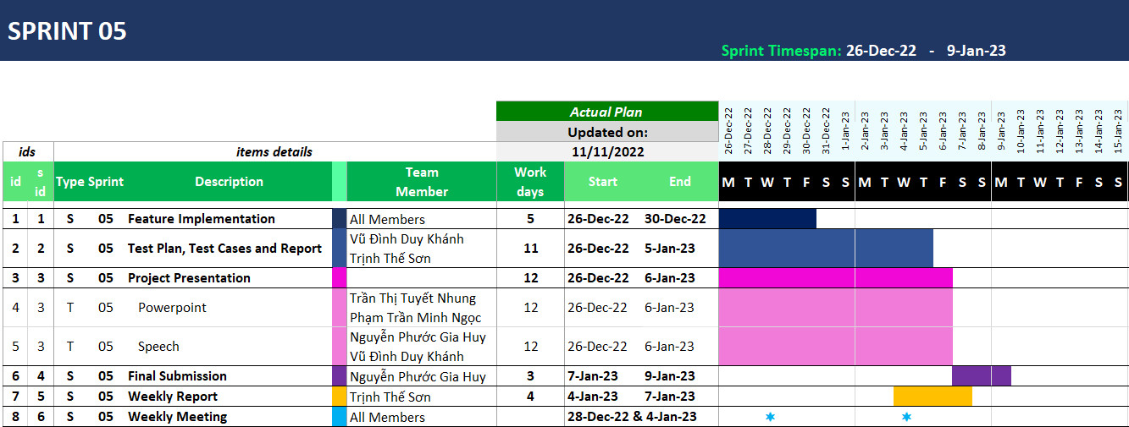

### **Sprint 06 - PA06**

(if our project has PA06, we will update later. )

### **Project Resourcing**

Our team has 5 members, so we are divided into 5 types of staff. These are Project Manager, Developer Front-end, Developer Back-end, Designer and Tester. And in our team, there is a person who has experience building a mobile app.

This project is about mobile application, so we are need to learn C# and xml.

## **Project Monitoring and Control**

### *Requirements Management*

The requirements for this system are captured in the Vision document. Requested changes to requirements are captured in Change Requests, and are approved as part of the Configuration Management process.

### *Reporting and Measurement*

Updated cost and schedule estimates, and metrics summary reports, will be generated at the end of each iteration.

The Minimal Set of Metrics, as described in the RUP Guidelines: Metrics, will be gathered on a weekly basis. These include:

Earned value for completed tasks. This is used to re-estimate the schedule and budget for the remainder of the project, and/or to identify need for scope changes.

Total defects open and closed – shown as a trend graph. This is used to help estimate the effort remaining to correct defects.

Acceptance test cases passing – shown as a trend graph. This is used to demonstrate progress to stakeholders.

In addition, overall costs will be monitored against the project budget.

### *Risk Management*

Risks will be identified in the Inception Phase using the steps identified in the RUP for Small Projects activity “Identify and Assess Risks”. Project risk is evaluated at least once per iteration and documented in this table. The risks of the greatest magnitude are listed first in the table.

| **Risk Ranking (High, Medium, Low)** | **Risk Description and Impact** | **Mitigation Strategy and/or Contingency Plan** |
| --- | --- | --- |
| High | **Risk description**: Some members have to learn new coding languages/technology in a limited time.  **Impact**: very hard and may cause some mistakes or overdue in the progress. | There must be coding training with other members in order to improve coding skill and experience, knowledge. |
| Medium | **Risk description**: The team's members may not completely understand the software making process.  **Impact**: cause confusion, members don’t know what to do. | There must be a well-made plan for each member and including personal deadlines in order to keep the project going smoothly. |
| Low | **Risk description**: The team’s members may have different time schedules and can not have an offline meeting.  **Impact**: Hard to communicate. | Setting up online meetings and workspace to work together. |

### *Configuration Management*

Appropriate tools will be selected which provide a database of Change Requests and a controlled versioned repository of project artifacts.

All source code, test scripts, and data files are included in baselines. Documentation related to the source code is also included in the baseline, such as design documentation. All customer deliverable artifacts are included in the final baseline of the iteration, including executables.